BREAKFAST CHATTER
Weekly Bulletin of Rotary Club of Kathmandu Mid-Town
District 3290 Volume No. 15/25 for #767 January 14, 2005
www.rotarymidtown.org.np
JANUARY IS ROTARY AWARENESS MONTH
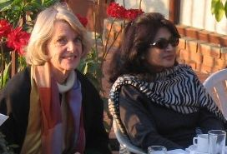
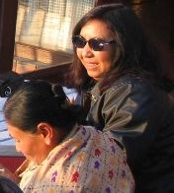
SUNSHINE ANNOUNCEMENT FOR THE WEEK OF 14 JANUARY, 2005;
Sunshine greetings to Mahendra and Monica on the 17th

*********** MEETING ACTIVITIES:
DATE | ACTIVITY | SUBJECT
14 JAN | CHERYL COLOPY | A Radio Journalist in Nepal
21 JAN | ADRA | Youth Reproductive Health Education Project (ABC)
28 JAN | CLUB ASSEMBLY | Financials etc
04 FEB | KRISHNA BHATTARAI | Achievements at HRDC
11 FEB | DEEPAK SHERCHAN | TBA
18 FEB | TBA | TBA
20 FEB | PICNIC | PLACE?? SUGGESTIONS WELCOMED
**************** NEWS: A quick survey: any suggestions for the site of a February picnic?? Is the 20th a good date?? Any big conflicts?? … Turnout for the Oceans 12 movie was good – thanks, Jyotsna! … Thanks also to Subarna for his insights on community mobilization. Rotary spouses appear in these three photos on their Thursday outing…
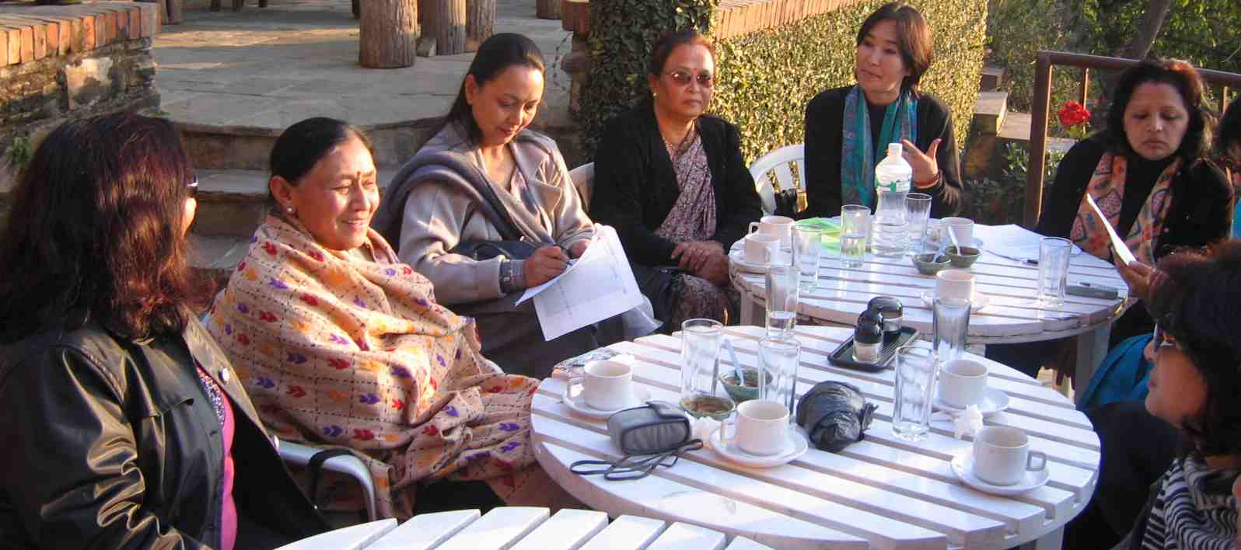
****************
**************** This Friday our speaker is Cheryl Colopy Returning for her second stay in Nepal, Cheryl brings a lively interest in Nepal’s people and in the environment, and a distinguished record as a radio journalist for National Public Radio (NPR) in the United States. YIR…David

